Name: ……………………………………………………
Class: ……………………………………………………… Score: …........................................
LISTENING TEST
Task 1: (Tactics, U.6, Task 2, p.22)
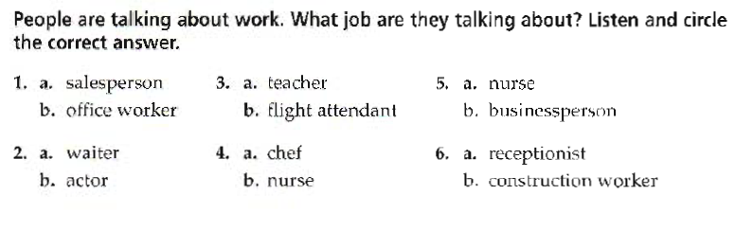
Task 2: (Tactics, U.6, Task 3.2, p.23)
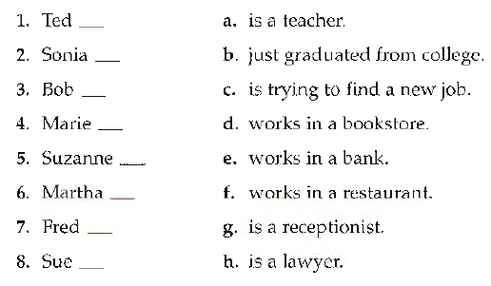
Task 3: (Tactics, U.6, Task 4.2, p.24)
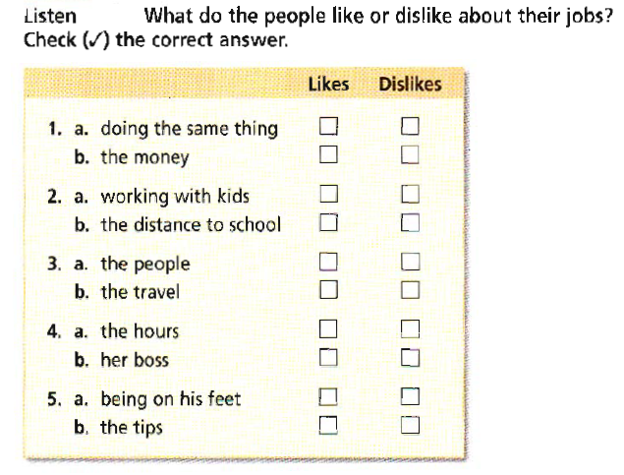
Task 4: (Tactics, U.7, Task 4.2, p.26)
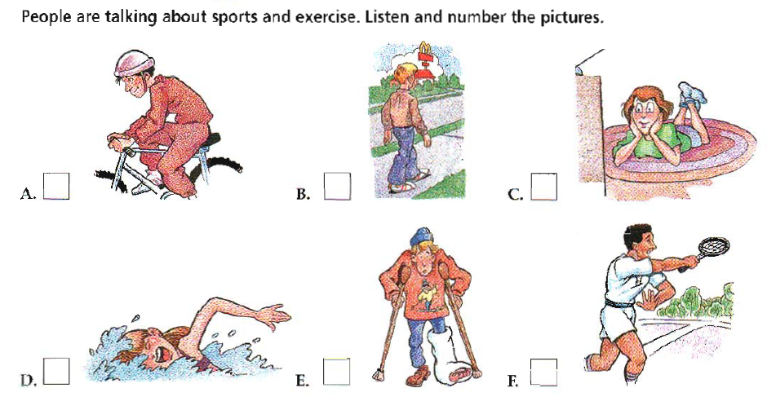
Task 5: (Tactics, U.8, Task 4.2, p.32)
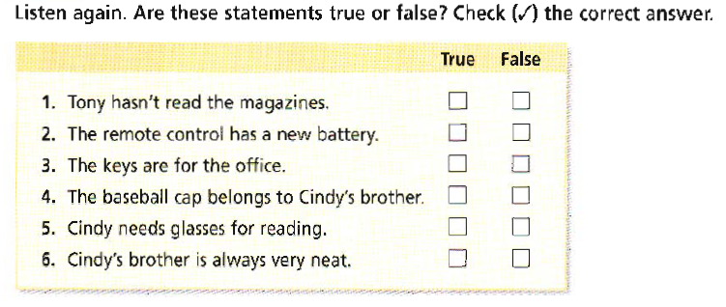
Task 6: (Tactics, U.9, Task 2, p.34)
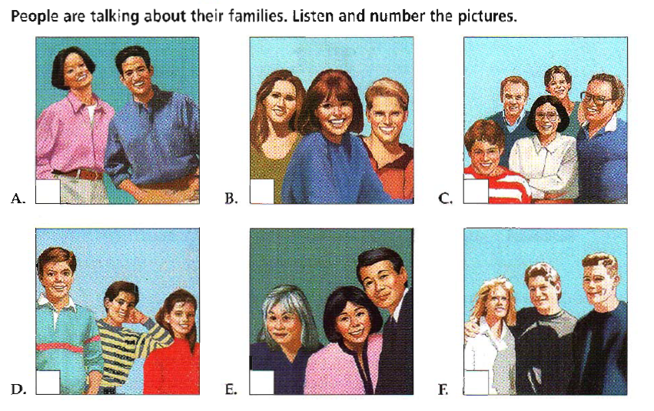
Task 7: Listen and fill in the blanks (Active 1, U.8, Expan 2)
Kuwait is a country in the (1)………………….. (2)………………. It’s located between Iraq and Saudi Arabia. Kuwait City is the (3)……………………. of the country. It is very modern and (4)……………………., and it is the (5) ………………………. of Kuwaiti (6)………………………. Today, Kuwaiti (7) …………………… is an (8)……………………. (9) …………………… of modern and (10)…………………….. (11) …………………… Kuwaitis like their modern (12)………………………but they also still enjoy their own (13)…………………….., too.


